Experiment 2 OUTPUTS:

**Implementation**

select sum(entry_fees) as Total_Revenue,spectator.depart from spectator group by cube(spectator.depart);

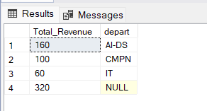

select sum(spec.entry_fees),spec.depart,g.game_id from game_stats gs,game g,spectator spec,location l where gs.game_id=g.game_id and gs.spec_id=spec.spec_id and gs.location_id=l.location_id group by cube(spec.depart,g.game_id);

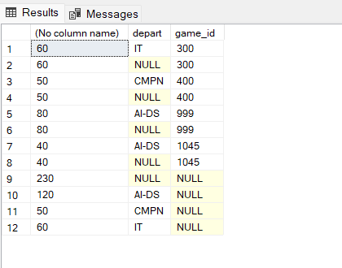

select sum(spec.entry_fees),spec.depart,g.game_id from game_stats gs,game g,spectator

spec,location l

group by cube(spec.depart,g.game_id);

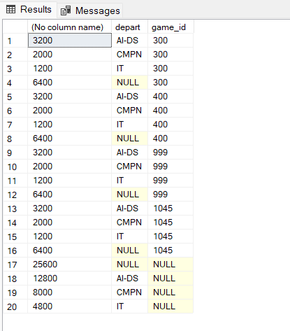

select sum(spec.entry_fees) Total_revenue,spec.depart,g.game_id,l.classroom from game_stats gs, spectator spec,game g,location l where gs.game_id=g.game_id and gs.spec_id=spec.spec_id and gs.location_id=l.location_id

group by cube(spec.depart,g.game_id,l.classroom);

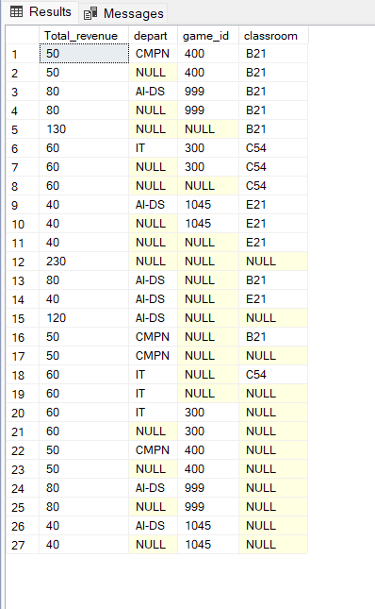

**Rollup:**

select sum(spec.entry_fees) as Total_Revenue,spec.depart,g.game_id,l.classroom from game_stats gs, spectator spec,game g,location l where gs.game_id=g.game_id and gs.spec_id=spec.spec_id and gs.location_id=l.location_id

group by rollup(spec.depart,g.game_id,l.classroom);

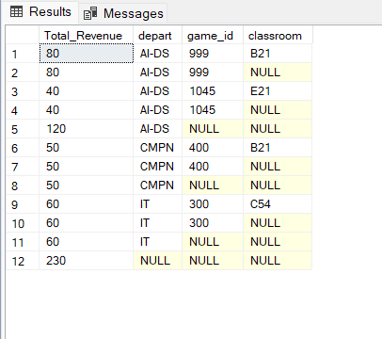

select sum(s.entry_fees) as Total_Revenue,s.depart,g.game_name from game_stats gs,spectator s,game g

where gs.game_id=g.game_id and gs.spec_id=s.spec_id group by rollup(s.depart,g.game_name);

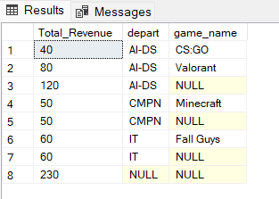

**Slice :**

select sum(spec.entry_fees) as Total_Revenue

,spec.depart,g.game_id,l.classroom

from game_stats gs, spectator spec,game g,location l where gs.game_id=g.game_id and gs.spec_id=spec.spec_id and gs.location_id=l.location_id

group by rollup(spec.depart,g.game_id,l.classroom) having spec.depart='AI-DS';

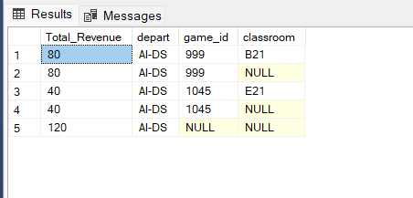

select sum(spec.entry_fees) as Total_Revenue,spec.depart,g.game_id,l.classroom from game_stats gs, spectator spec,game g,location l where gs.game_id=g.game_id and gs.spec_id=spec.spec_id and gs.location_id=l.location_id

group by rollup(spec.depart,g.game_id,l.classroom) having g.game_id='1045';

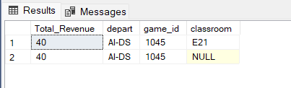

select sum(spec.entry_fees) Total_Revenue,spec.depart,g.game_id,l.classroom from game_stats gs, spectator spec,game g,location l where gs.game_id=g.game_id and gs.spec_id=spec.spec_id and gs.location_id=l.location_id

group by rollup(spec.depart, g.game_id,l.classroom) having l.classroom='E21';

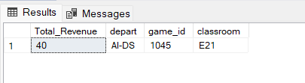

**Dice** :-

select sum(spec.entry_fees) as Total_Revenue,spec.depart,g.game_id,l.classroom from game_stats gs, spectator spec,game g,location l where gs.game_id=g.game_id and gs.spec_id=spec.spec_id and gs.location_id=l.location_id

group by cube(spec.depart,g.game_id,l.classroom) having l.classroom in('E21','B21') or

g.game_id in(999,1045) or spec.depart in('AI-DS','IT');



